**--- Reducing Energy supply Risks and CO2 emission are the major motivators for governments to invest in EV market—(green )**

**Electric Vehicle Global Market**

in past decade climate change and difficult access to sustainable energy have motivated governments around the world to set a goal to achieve sustainable green transportation. Electrical Vehicles (EV) is one of the possible way to reduce dependence on petroleum and reduce emission of CO2 and other pollutants. Therefore, a number of governments around the world are establishing deployment goals for EVs, automobile industry are researching on this technology shift, launching variety of new EVs models to the market and trying to reduce the cost of components to encourage costumers with different budget levels to purchase this advanced technology.

**EVs Global landscape in 2014**

Governments around the world for achieving their goal which are increasing energy security and reducing the emission of greenhouse gases have set some EVs stock targets .below figure shows the EVs stock situation in 15 countries which have hold 95% of global EVs stock and electrical vehicle supply equipment stock.

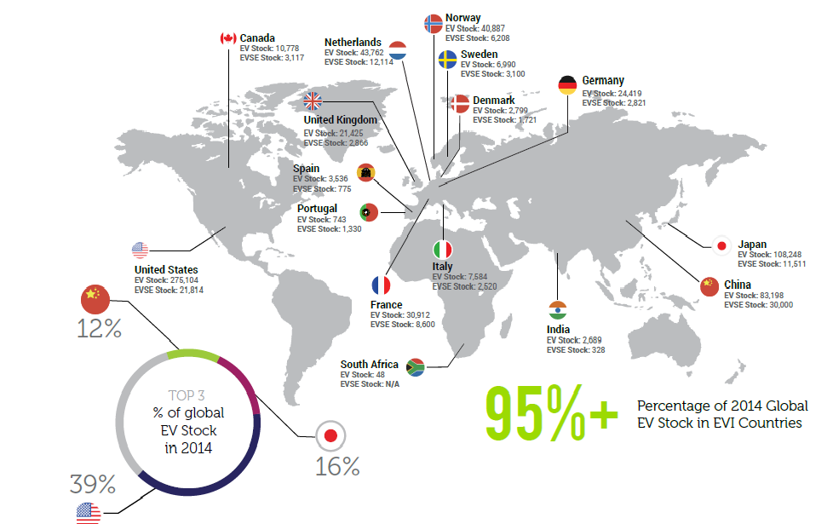

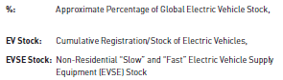

As can be seen from this figure, countries with petroleum access concern have set plan for increasing the use of EVs which can result in saving in energy, but petroleum producing and exporting countries has been lagged terribly behind the rest of the world in deployment of EVs .

**EV Sales Target**

Most countries and policy makers has set a long term EV sale target in the relative near term 2010-2020 time frame to accelerate sale and use of EV in their own country .

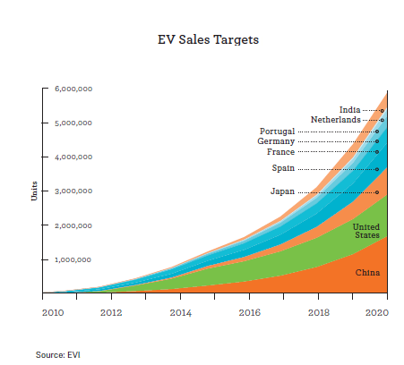

As can be seen from this figure , the EV target sale for India and China as countries with high population have a significant difference with each other. India’s EV sale target will reach to 6 million at the end of 2020 while China has planned to reach to 1 million. This variance can be result of the ability of government to access sustainable energy.

**EV Market Share**

Market shares of EV vary significantly across the world. As can be seen from below figure, Norway has the highest share of EV sales with about 12.5% of all passenger cars sold in 2014. The Netherlands has the second highest market share, with about 3.9%**.** The structures of the two markets are entirely different, While in Norway nearly all EVs sold are battery electric vehicle (BEVs), in the Netherlands plug in hybrid electric vehicle (PHEVs) clearly account for the majority of the market. Italy has the lowest share of EVs with about 1% .

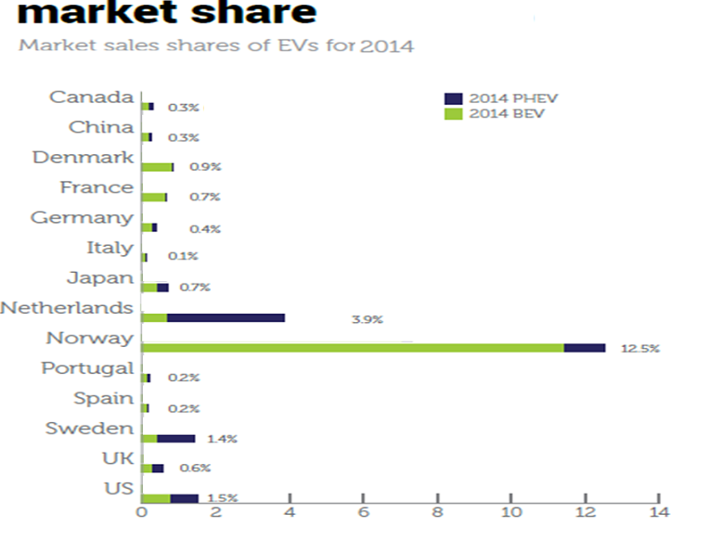

**---** Norway has the highest share of EV sales with 12.5% of all passenger cars sold in 2014(gray)----

**World EV Models Sales**

EV manufacturer are competing over the market share and each year launch new models to the market to satisfy different target costumers. Below chart shows top 10 EV models which had the highest worldwide sale.

---Nissan Leaf is EV Market leader 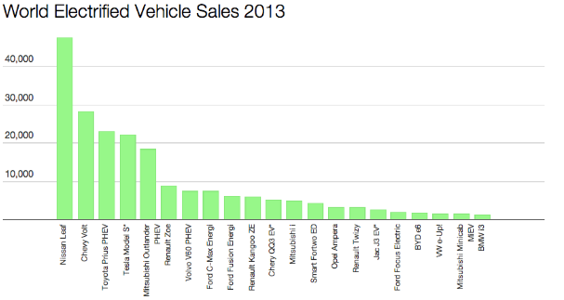(gray)----

Source: http://evobsession.com

As can be seen from this chart, Nissan Leaf is the Market leader which has almost twice as many sale as the Chevy Volt .

As can be seen from the chart, the large majority of EV sales come from the top 5 models in 2013 which are representing 67% of all EVs sales. As being in stages of EV revolution the rankings can change very fast as the result of technology improvement and launching new EVs models by manufacturers.

**Conclusion:**

The road ahead of EV market globalization is very long and not easy , EV market share are still around 1% in most major markets, but governments and manufacturers try to deal with all obstacles look like high battery cost, EV range limitation, low costumer acceptance to spread the usage of EV between different levels of society .EV market is very naïve and future of the market is belong to companies that can come up with new ideas and better battery technology to face with challenges and launch better products to market .